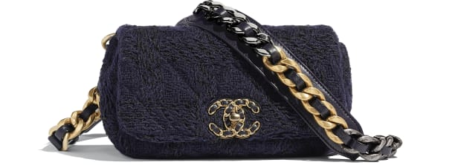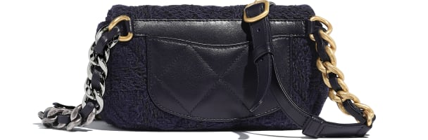

CHANEL 19 Waist Bag

Wool Tweed, Gold-Tone, Silver-Tone & Ruthenium-Finish Metal

Navy Blue & Black

11 × 20 × 5 cmin

Reference: AS1163 B01624 MH059

**CAN$4,200**